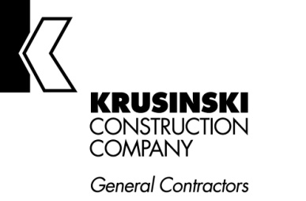

Summer Internship – 2022

Opportunity: Marketing Intern/Paid

COMPANY: Krusinski Construction Company (KCC), a leading general contractor for nearly 50 years, is seeking a motivated and enthusiastic marketing intern for summer 2022. We are looking for a team player seeking a dynamic company and culture. This individual will work with the corporate marketing team in Oak Brook, IL.
Visit our website at www.krusinski.com for more information about our company culture, history and projects.

POSITION DESCRIPTION: We are seeking a student to work part-time, Monday-Thursday from 8:30-4:30 in our marketing department, under the direction of the marketing team leadership, alongside experienced marketing professionals. The intern for the marketing department will play an active role in KCC’s marketing activities which include proposal generation, social media, public relations, page layout, administrative tasks, and website assistance. An essential duty will be helping to finalize and roll out the firm’s new Customer Relationship Management (CRM) software, Cosential.
DESIRED SKILLS:
  - Pursing an undergraduate degree in Marketing, Communication/PR, Journalism, or a related field
  - Solid and detailed written communication skills
  - Strong analytical and communication skills
  - Ability to be a self-starter and work collaboratively
  - Graphic design skills are preferred but not required
  - Solid work ethic

CONTACT: Please send resumes to Gina Krusinski at ginak@krusinski.com

